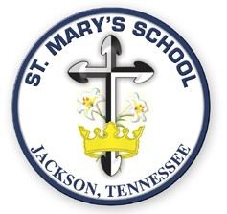
1665 Highway 45 By-Pass
Jackson, Tennessee 38305
731-668-2525
www.stmarysschool.tn.org

DIOCESE OF MEMPHIS

ST. MARY’S SCHOOL

CONTRIBUTING CATHOLIC VERIFICATION FORM

____________________________________________ is a contributing member of
Parent (s) Name

_______________________________________ and should receive the appropriate
Name of Parish

tuition rate from St. Mary’s School for the 2024-2025 school year.

____________________________________ entering __________ grade.
Student’s Name

___________________________________ _____________________
Signature of Pastor Date

Parent(s) are responsible for the completion and return of this form to St. Mary’s
School.

“I came that they may have life and have it to the full.” John 10:10

LEARNING FOR LIFE IN THE CATHOLIC SCHOOL TRADITION

