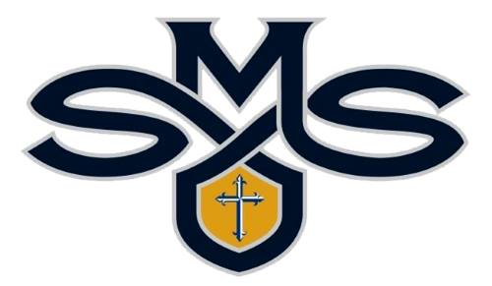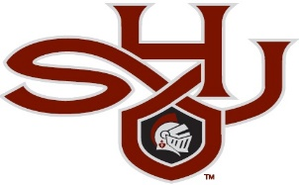
JOIN TODAY!!!
The Mission of St Mary’s/Sacred Heart Athletic Booster Club
The mission of the Athletic Booster Club is to build pride, a sense of unity, and interdependence among parents, staff, and the supporters of the SMS/SHJHS student-athletes. Booster club members also assist in developing the whole student: one's body, mind, spirit and character through Christ-like self-discipline, dauntless dedication, selfless efforts, the development of innate talent and abilities, sportsmanship, and teamwork.
***Meetings are the 2nd Wednesday of every month, at 6:00PM in The Holy Family Hall at St Mary’s Church. See you there!
2021-2022 OFFICERS
President Gabi Cox 731- 225-4844 gabrielle.cox@hotmail.com
Vice President Triniti Perkins 317-656-1322 triniti.perkins@stmarys.tn.org
Vice President Amy Evans 731-343-2194 amy.evans@stmarys.tn.org
Secretary Jessica Plunk 731-695-2512 jeplunk76@yahoo.com
Treasurer OPEN
Concessions OPEN OPEN OPEN

NEW THIS YEAR
- In order to have full representation from all athletic teams, the Athletic Booster Club is requiring a Parent Representative from each team. This parent representative will communicate to the booster club game scores, player and program highlights, as well as attend the fun monthly meetings! Look for a communication from your coaches.

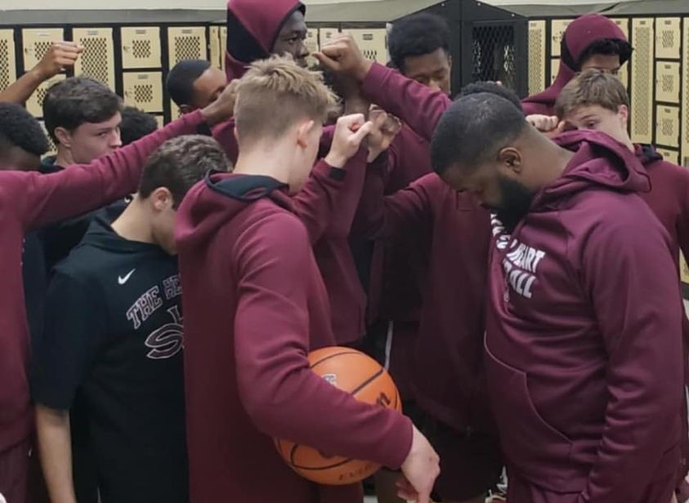
WHY SHOULD I JOIN?
IT HELPS YOUR CHILD AGES K-12
• Your donation works to benefit All sports for All students and All teams. Building programs that can develop students’ greatest potential through sportsmanship, self-discipline, and perseverance, now and into the future.
IT HELPS THE SCHOOL
• Positive support creates a positive, thriving athletic program and contributes to a positive school atmosphere.
IT HELPS YOU
• All donations are tax deductible
• Being involved builds friendships and allows you an opportunity to be an important part of the SMS/SHJHS Community
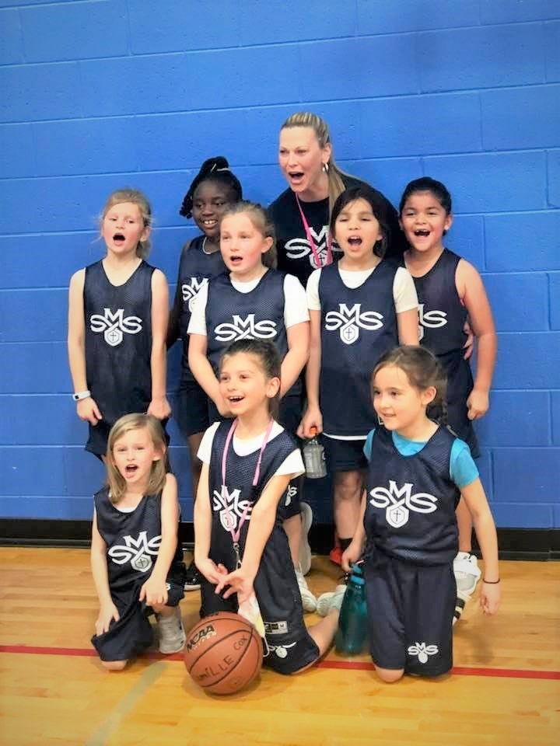
BECOME A MEMBER TODAY!
If you are interested in a Christ-centered environment that nurtures academic and athletic success… a program that emphasizes excellence, integrity, and sportsmanship…schools that will help you develop the students’ talents and grow as a young lady and gentleman.... Take a closer look at St Mary’s/Sacred Heart’s Catholic Athletic Booster Club!
***Membership and meetings in the St Mary’s/Sacred Heart Athletic Booster Club (Boosters) is open to all coaches, faculty, parents of students and alumni.
HANDS-ON MEMBERSHIP
- Your name to appear in the Athletic Section of our social website/s
$25.00 PATRON MEMBERSHIP
- Your name to appear in the Athletic Section of our social website/s
- 1 SMS or SHJHS car magnet

$50.00 PATRON MEMBERSHIP
- Your name to appear in the Athletic Section of our social website/s
- 1 SMS or SHJHS car magnet
- 1 SMS or SHJHS yard sign

$100 PATRON MEMBERSHIP
- Your name to appear in the Athletic Section of our social website/s
- 2 SMS or SHJHS car magnets
- 1 SMS or SHJHS yard signs
- 1 Complimentary Spirit Wear T-Shirt
- 2 All Sport Access Passes for 2021-2022 school year

$250 PATRON MEMBERSHIP
- Your name to appear in the Athletic Section of our social website/s
- 2 SMS or SHJHS car magnets
- 2 SMS or SHJHS yard signs
- 1 Complimentary Spirit Wear T-Shirt
- 4 All Sport Access Passes for 2021-2022 school year

$500+ PATRON MEMBERSHIP
- Your name to appear in the Athletic Section of our social website/s
- 2 SMS or SHJHS car magnets
- 1 SMS or SHJHS yard signs
- 2 Complimentary Spirit Wear T-Shirts
- Unlimited All Sport Access Passes for 2021-2022 school year

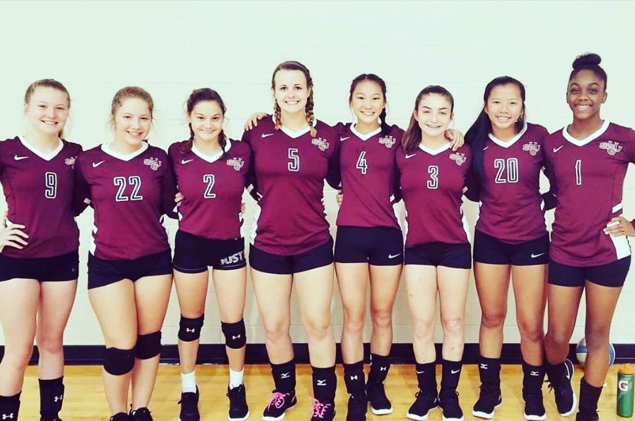

BOOSTER CLUB BANNER SPONSORSHIPS

Color banner displayed in both gymnasiums, baseball field,
softball field, soccer/football field

Indoor OR Outdoor banner only:
- Five Years – $1,500 (total)
- Four Years – $1,250
- Three Years – $1,000
- Two Years – $750
- One Year – $500

Indoor AND Outdoor Banners:
- Five Years – $3,000 (total)
- Four Years – $2,500
- Three Years – $2,000
- Two Years – $1,500
- One Year – $1,000

***File requirements: -Acceptable files for logos include AI, EPS and VECTOR
If you need assistance creating your banner, please contact Gabi Cox by
email at gabrielle.cox@hotmail.com

WHERE DOES YOUR INVESTMENT GO?
We support all athletic programs by funding:
- Team Uniforms Equipment Storage
- Sports Equipment Sports Banquets
- Team travel Costs Hospitality for Referees, Judges, Clinicians
- Sports Facilities Maintenance Media Coverage Costs
- Field Improvements Promotional Items
- Concessions Stats Software
HOW DO WE RAISE MONEY?
- Membership Corporate Sponsorships
- Merchandise Sales Annual Crawfish Boil
- Concessions Beer & Brats Fall Festival
This is truly a community effort as it involves businesses and individuals coming together to support our schools’ athletes. All of these fundraising activities rely on your generous donations of time, money, and commitment to our student athletes.

